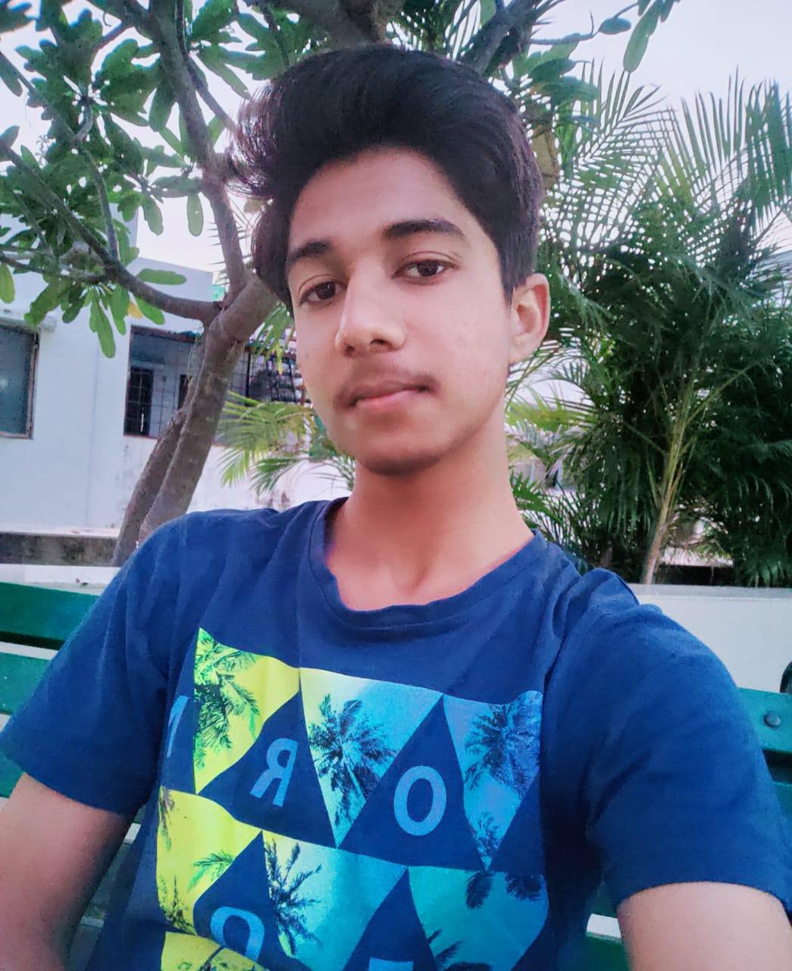

Dev Maheshwari

C++, Python developer, Backend developer, Database management(SQL)

Minor—Data analysis, Big data(Hadoop)

Future tech—Mongo db, scikit learn

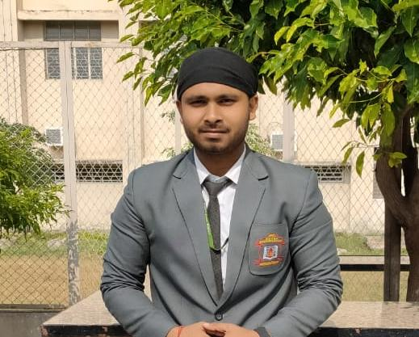

Aman Kumar

Java, Python developer, Android developer,

Html, css

Minor— Digital marketing, game development.

Future tech—Flutter

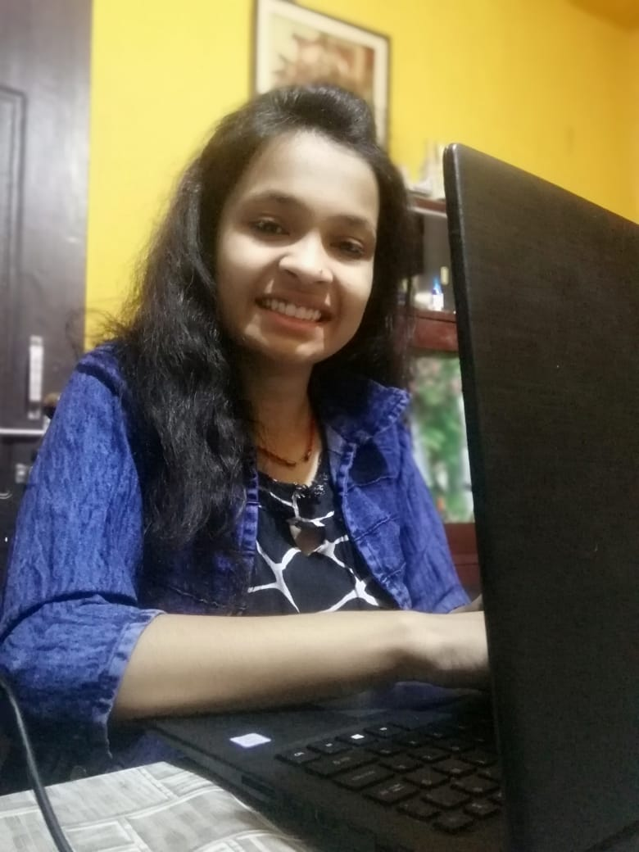

Richa Raikwar

Java , Python developer, Front-end developer, Bootstrap, UI.

Minor—Data analysis

Currently working-- Angular



Massoom Khan

Python developer, Front-end developer,Software UI, Linux

Minor—Cyber Security, Tkinter

Future tech— Further dealing with cyber security